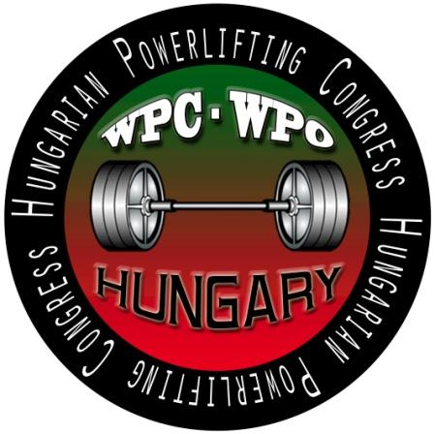
WUAP European Championships 2016
Powerlifting + benchpress
RAW + EQUIPPED
Date: 15-18. June 2016
Organizer: Magyar Erőemelő Profi Liga; Body Fit SE
Director: Süli Tibor (+36-70-201-7592)
Technical director: Freimann Sándor (+36-30-520-9193)
E-mail: hungarianpowerliftingcongress@gmail.com
www.powerlifting.hu www.wuap-powerlifting.com
Venue: Gyula, Sport Hall – 5300 Gyula, Ajtóssy út 2-10.

Weigt-in
Tuesday, 14.06.2016. (for Wednesday competitors)
16:00 – 19:00 Benchpress RAW +EQ (Men: masters, junior, teens)
Wednesday, 15.06.2016. (for Wednesday competitors)
07:30– 09:00 Benchpress RAW+EQ (Men: masters, junior, teens)
Wednesday, 15.06.2016. (for Thursday competitors)
09:30-11.00 and 16:00 – 19:00 Benchpress RAW+EQ (all women; men: open, submasters)
Thursday, 16.06.2016. (for Thursday competitors)
07:30 – 09:00 Benchpress RAW+EQ (all women; men: open, submasters)
Thursday: 16.06.2016. (for Friday competitors)
09:30 - 11:00 and16:00 – 19:00 Powerlifting RAW + EQ (Men: masters, junior, teens)
Friday, 17.06.2016. (for Friday competitors)
07:30 – 09:00 Powerlifting RAW + EQ (Men: masters, junior, teens)
Friday, 17.06.2016. (for Saturday competitors)
09:30 - 11:00 and 16:00 – 19:00 Powerlifting RAW +EQ (all women; men: open, submasters)
Saturday, 18.06.2016. (for Saturday competitors)
07:30 – 09:00 Powerlifting RAW + EQ (all women; men: open, submasters)

Competition
Opening ceremony: 09:30
Wednesday (15.06.) – Start 10:00 – RAW+EQ Benchpress (men: masters, junior, teens)
Thursday (16.06.) – Start 10:00 – RAW+EQ Benchpress (all women; men: open, submasters)
Friday (17.06.) - Sart 10:00 – RAW+EQ Powerlifting (men: masters, junior, teens))
Saturday (18.06.) – Start 10:00 – RAW+EQ Powerlifting (all women; men: open, submasters)
Saturday: after the closing ceremony – banquet!
The organizer reserves the right to change schedule to the date of deadline of the entry form (30th May 2016)
Rules: The EUROPE Championships is organised and will be held by the WUAP rules.
These rules are available on the official site of WUAP: www.wuap-powerlifting.com
With the nomination the athlete accepts the rules of the federation "WUAP" and is automatically an extraordinarily member of the federation. 10% of the participating athletes will be tested if they are drug free. If somebody should be positive, he/she will be excluded from the meeting; the entry fee will be not returned. The result of the test is final.

Deadline for the entryform and fee: May 30th 2016
After May 30th 2016 no late entry’s will be accepted!

Entryfee:
Open, submasters category:
Benchpress EQ: □ € 65,- Powerlifting EQ: □ € 65,-
Benchpress RAW: □ € 65,- Powerlifting RAW: □ € 65,-

Teens, juniors and masters will pay 50€
Each additional start will be 40€ (all category)
Closing day of the entry: 30th May 2016

Online entry www.powerlifting.hu (English version)
The entry fees have to be transferred by the closing day
Bank: Rajka és Vidéke Takarékszövetkezet
Address of the Bank: H-9200 Mosonmagyaróvár, Palánk u. 8.
SWIFT-code: TAKBHUHB
Owner of the account: Hungarian Powerlifting Congress
Owner of the account’s address: H-9200 Mosonmagyaróvár, Kálnoki u. 11.
IBAN: HU82 5950 0155 5001 3667 0000 0000
We ask you to write the name of the competitors to the „Notice for transfer”
Information: hungarianpowerliftingcongress@gmail.com
Website: www.powerlifting.hu www.wuap-powerlifting.com

Accomodation: www.visitgyula.com
Transfer:
Budapest Airport – Gyula 45€ (1 person/1 way)
Debrecen Airport – Gyula 25 € (1 person/1 way)

